python interview questions and answers for experienced developers

Here are some advanced Python interview questions with answers aimed at experienced developers:

1. Explain Python's Global Interpreter Lock (GIL) and how it affects concurrency.
Answer: The Global Interpreter Lock (GIL) is a mutex in CPython (the standard Python implementation) that allows only one thread to execute at a time, even in multi-threaded programs. The GIL simplifies memory management but limits the execution of CPU-bound multi-threaded applications, as threads cannot run in parallel. However, the GIL doesn’t affect I/O-bound tasks as threads can release the GIL when waiting for I/O. For true parallelism, developers use the multiprocessing module, which spawns multiple processes instead of threads, each with its own GIL.

2. How does Python manage memory?
Answer: Python manages memory using a private heap containing all objects and data structures. Memory allocation for objects and structures is managed by Python's memory manager, while Python's built-in garbage collector handles memory cleanup. The garbage collector uses reference counting to deallocate objects with no references and has a cyclic garbage collector to detect and collect objects in reference cycles. For efficiency, Python uses a memory pool allocation method, known as pymalloc, for small objects.

3. What are Python decorators, and how would you use them in a real-world application?
Answer: Decorators are a way to modify or extend the behavior of functions or methods without permanently modifying their source code. A decorator is a higher-order function that takes a function as input and returns a new function with added functionality. In real-world applications, decorators are commonly used for logging, access control, caching, and timing. For example:
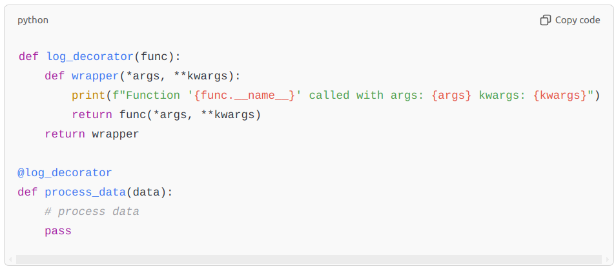
python
Copy code
def log_decorator(func):
def wrapper(*args, **kwargs):
print(f"Function '{func.__name__}' called with args: {args} kwargs: {kwargs}")
return func(*args, **kwargs)
return wrapper

@log_decorator
def process_data(data):
# process data
pass

4. What is the difference between deep copy and shallow copy in Python?
Answer: A shallow copy creates a new object, but does not create copies of nested objects. Instead, it just copies references to the original nested objects. You can create a shallow copy using the copy module’s copy() function or slicing.
A deep copy, on the other hand, creates a new object and recursively copies all nested objects as well. This ensures that modifying a nested object in the copied object does not affect the original. Deep copies can be created using copy.deepcopy().

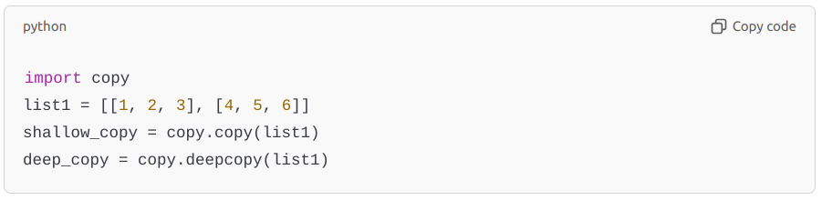
python
Copy code
import copy
list1 = [[1, 2, 3], [4, 5, 6]]
shallow_copy = copy.copy(list1)
deep_copy = copy.deepcopy(list1)

5. What is a generator in Python, and how does it differ from a regular function?
Answer: A generator is a special type of function that yields values one at a time using the yield keyword instead of return, allowing it to produce a sequence of results lazily. Unlike a regular function that returns a single value and terminates, a generator maintains its state and can be resumed from where it last yielded. Generators are memory efficient and useful for working with large data streams.

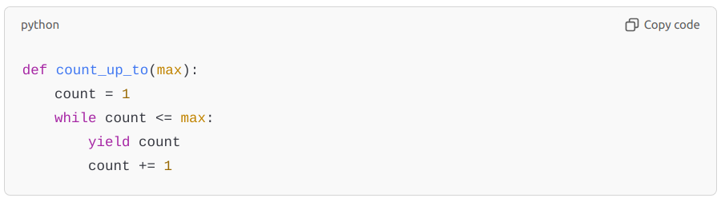
python
Copy code
def count_up_to(max):
count = 1
while count <= max:
yield count
count += 1

6. Explain the asyncio module and how it is used in asynchronous programming.
Answer: The asyncio module provides support for asynchronous programming by enabling concurrent code execution via async and await keywords. It’s suitable for I/O-bound and high-level structured network code, such as web servers or database interactions. Functions defined with async can use await to yield control back to the event loop, allowing other tasks to run.
Example:
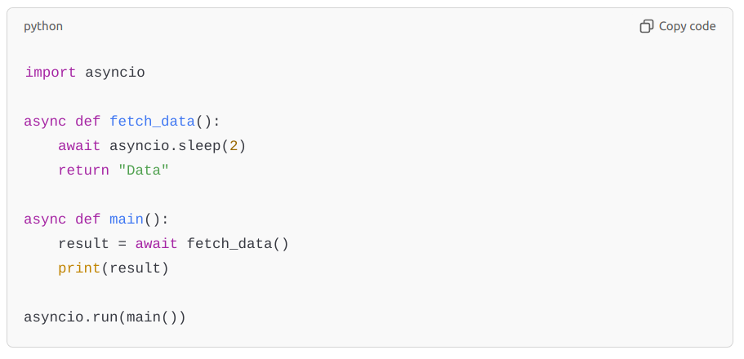
python
Copy code
import asyncio

async def fetch_data():
await asyncio.sleep(2)
return "Data"

async def main():
result = await fetch_data()
print(result)

asyncio.run(main())

7. How can you optimize Python code performance?
Answer:
- Use built-in functions and libraries as they are implemented in C and optimized for performance.
- Avoid using global variables, as local variable access is faster.
- Use list comprehensions and generator expressions instead of traditional loops.
- Minimize attribute lookups by storing repeated lookups in local variables.
- Leverage caching with functools.lru_cache for functions with repeatable results.
- Use multiprocessing or asyncio for parallelism and concurrency when suitable.
- Profile code using modules like cProfile or timeit to identify bottlenecks.

8. What is monkey patching in Python? Give an example.
Answer: Monkey patching is the practice of modifying or extending code at runtime. This technique is often used to add functionality to or modify the behavior of libraries without altering their source code. However, it should be used cautiously as it can lead to code that is hard to understand and maintain.
Example:
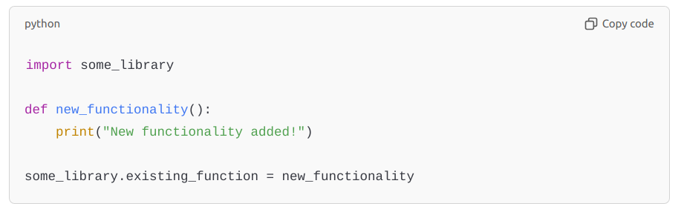
python
Copy code
import some_library

def new_functionality():
print("New functionality added!")

some_library.existing_function = new_functionality

9. What are metaclasses in Python, and why would you use one?
Answer: A metaclass is a class of a class that defines how a class behaves. Just as an instance is created from a class, a class itself is created from a metaclass. Metaclasses allow for customization of class creation, which is useful for enforcing certain structures or automatically registering classes.
Example use case:
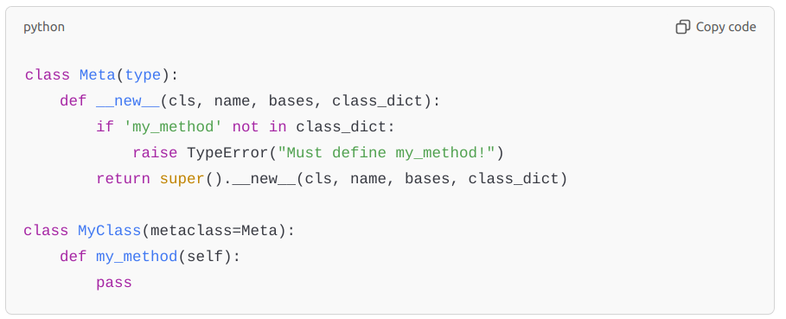
python
Copy code
class Meta(type):
def __new__(cls, name, bases, class_dict):
if 'my_method' not in class_dict:
raise TypeError("Must define my_method!")
return super().__new__(cls, name, bases, class_dict)

class MyClass(metaclass=Meta):
def my_method(self):
pass

10. What are some differences between Python 2 and Python 3?
Answer:
- Print statement: Python 2 uses print "Hello" whereas Python 3 requires parentheses: print("Hello").
- Integer division: 5/2 in Python 2 returns 2, while in Python 3 it returns 2.5. In Python 3, // is used for integer division.
- Unicode: Python 3 uses Unicode by default for str objects, while Python 2 uses ASCII.
- range vs. xrange: Python 2 has xrange for lazy sequences, but in Python 3, range returns an iterator.
- Error handling syntax: Python 2 uses except Exception, e, while Python 3 uses except Exception as e.
These questions probe both deep knowledge of Python and understanding of best practices in software engineering, which is crucial for experienced developers.

Here are some additional advanced Python interview questions that dive deeper into Python’s functionality and concepts:

11. What is the difference between __str__ and __repr__ in Python?
Answer: __str__ and __repr__ are both special methods used to define string representations of objects.
- __str__ is intended to provide a "user-friendly" output, often more readable, meant for end-users.
- __repr__ is intended to provide an "official" string representation that could be used to recreate the object (often more verbose) and is generally aimed at developers.
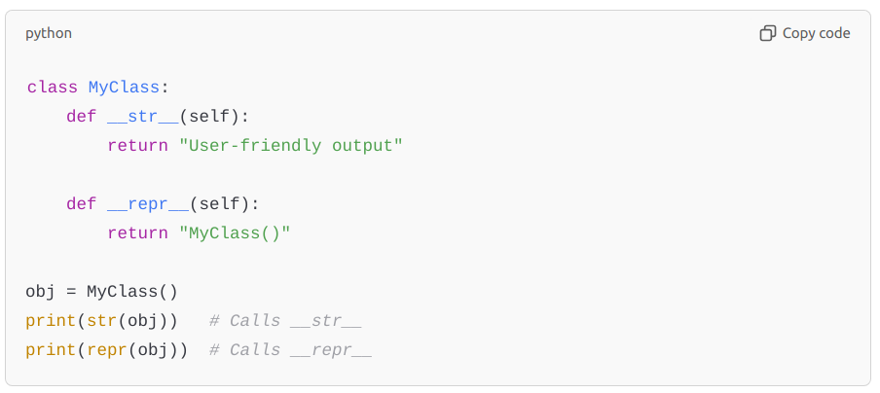
python
Copy code
class MyClass:
def __str__(self):
return "User-friendly output"

def __repr__(self):
return "MyClass()"

obj = MyClass()
print(str(obj)) # Calls __str__
print(repr(obj)) # Calls __repr__

12. Explain the concept of @property in Python and how it is used.
Answer: The @property decorator allows a method to be accessed like an attribute, making it easier to define getter, setter, and deleter functionality without directly exposing an attribute. It’s useful for defining read-only attributes or computed properties.
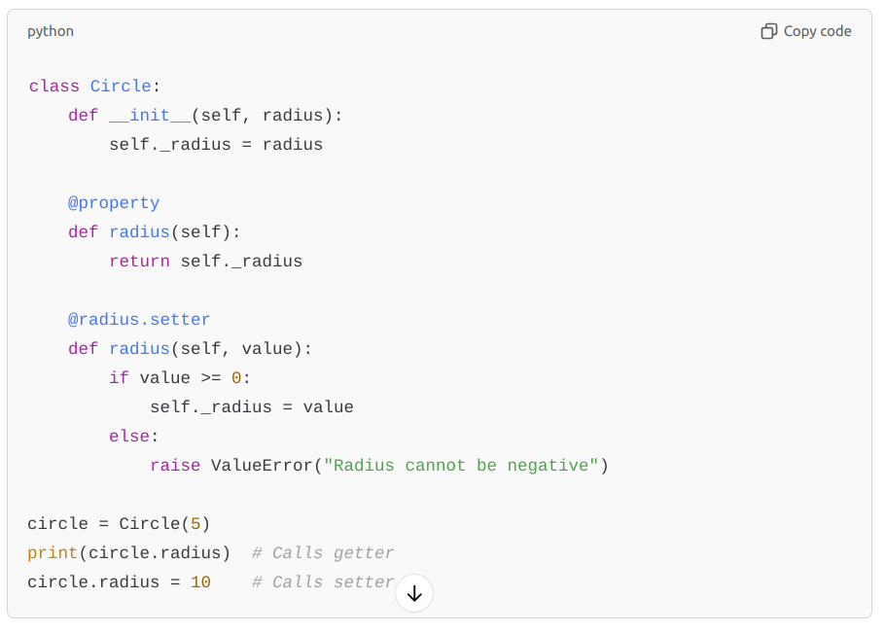
python
Copy code
class Circle:
def __init__(self, radius):
self._radius = radius

@property
def radius(self):
return self._radius

@radius.setter
def radius(self, value):
if value >= 0:
self._radius = value
else:
raise ValueError("Radius cannot be negative")

circle = Circle(5)
print(circle.radius) # Calls getter
circle.radius = 10 # Calls setter

13. How would you handle circular imports in Python?
Answer: Circular imports occur when two or more modules depend on each other, creating an import loop. To handle circular imports:
- Restructure code to minimize interdependencies.
- Move imports into functions or methods to defer them until necessary.
- Use import statements at the end of the module if the modules are only needed conditionally.
- Alternatively, refactor code to combine interdependent modules or use a common module to avoid cyclical references.

14. What is the difference between is and == in Python?
Answer: is checks for object identity (whether two references point to the same object in memory), while == checks for value equality (whether the objects have the same value). For example:
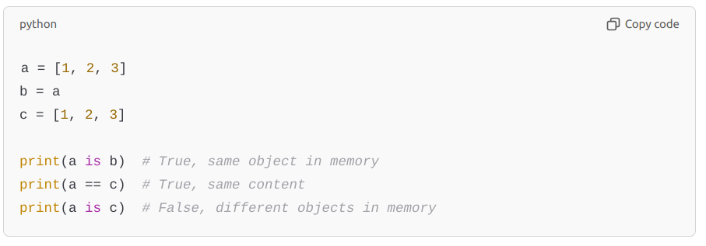
python
Copy code
a = [1, 2, 3]
b = a
c = [1, 2, 3]

print(a is b) # True, same object in memory
print(a == c) # True, same content
print(a is c) # False, different objects in memory

15. What are __slots__ and when would you use them?
Answer: __slots__ is a special class variable that can be used to restrict the creation of instance attributes to a predefined set. It can save memory by preventing the creation of __dict__ for each instance, which is useful in memory-constrained environments or for optimizing performance in classes with a large number of instances.
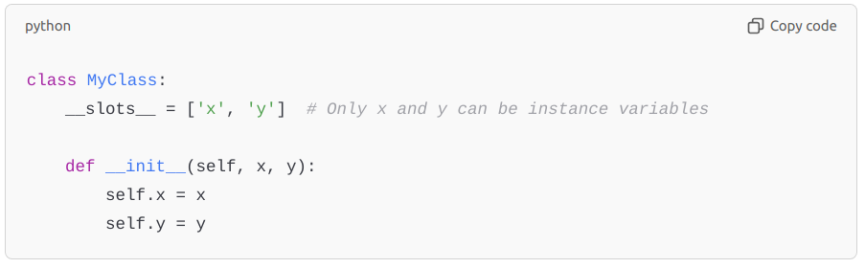

16. What is a lambda function, and how is it used?
Answer: A lambda function is an anonymous, inline function defined with the lambda keyword, typically used for short functions where defining a full function with def would be cumbersome. They are used in situations where a small function is needed temporarily, often as an argument to higher-order functions.
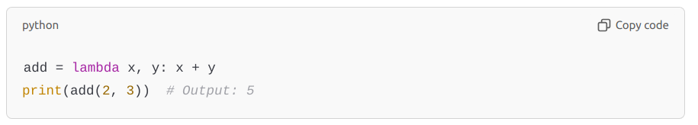

17. Explain the use of with statement and context managers in Python.
Answer: The with statement simplifies exception handling by encapsulating setup and teardown code, making it ideal for resource management (e.g., files or network connections). A context manager implements the __enter__ and __exit__ methods to manage resources.
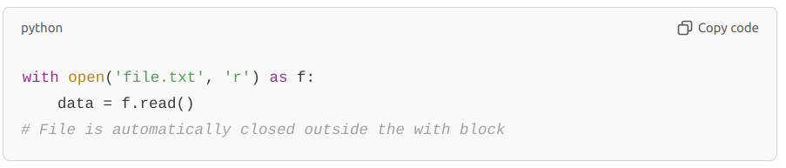

18. What is the purpose of functools.lru_cache, and how does it work?
Answer: functools.lru_cache is a decorator for caching the results of function calls, which can speed up repeated computations by storing the results of previous calls. lru_cache stands for "Least Recently Used" cache, meaning it removes the least recently accessed items when the cache reaches its maximum size.
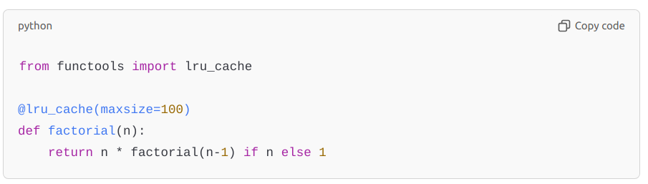
python
Copy code
from functools import lru_cache

@lru_cache(maxsize=100)
def factorial(n):
return n * factorial(n-1) if n else 1

19. Explain the concept of duck typing in Python.
Answer: Duck typing is a programming concept where an object's suitability for use is determined by the presence of certain methods and properties, rather than the actual type of the object. In Python, if an object behaves like a certain type, it can be used as that type, promoting flexibility.
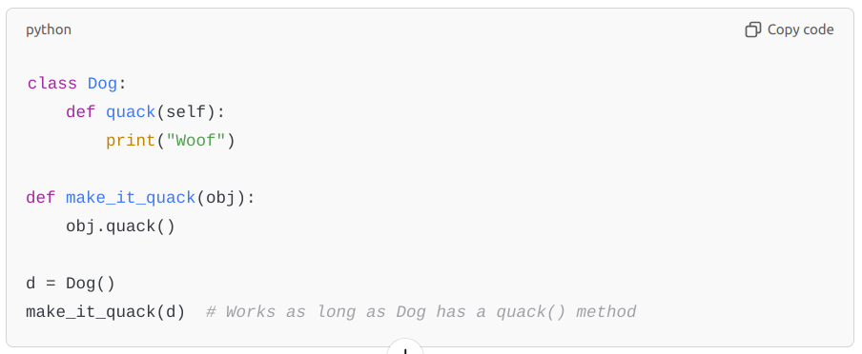
python
Copy code
class Dog:
def quack(self):
print("Woof")

def make_it_quack(obj):
obj.quack()

d = Dog()
make_it_quack(d) # Works as long as Dog has a quack() method

20. What are coroutines, and how do they differ from regular functions?
Answer: Coroutines are a type of function that can pause and resume execution, often used for asynchronous programming. Defined with async def and controlled with await, coroutines differ from regular functions in that they yield control back to an event loop instead of blocking the execution.
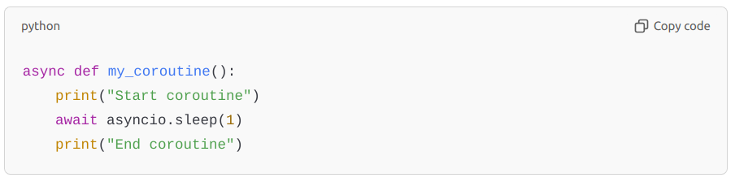
python
Copy code
async def my_coroutine():
print("Start coroutine")
await asyncio.sleep(1)
print("End coroutine")

21. How do you implement a singleton pattern in Python?
Answer: A singleton pattern ensures a class has only one instance and provides a global access point to it. In Python, a common way to implement this is by overriding the __new__ method.
python
Copy code
class Singleton:
_instance = None

def __new__(cls, *args, **kwargs):
if not cls._instance:
cls._instance = super(Singleton, cls).__new__(cls, *args, **kwargs)
return cls._instance

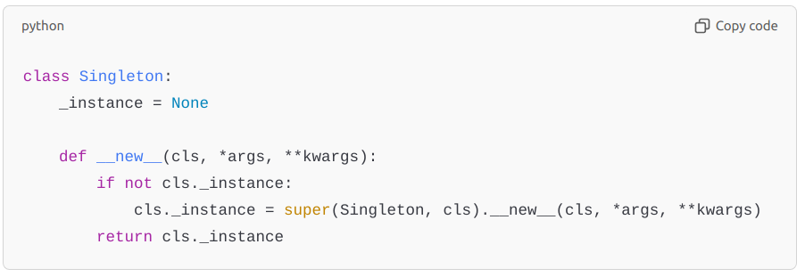
22. What are the *args and **kwargs parameters in Python, and how are they used?
Answer: *args and **kwargs allow functions to accept variable numbers of arguments.
- *args is used to pass a variable number of positional arguments.
- **kwargs is used to pass a variable number of keyword arguments.

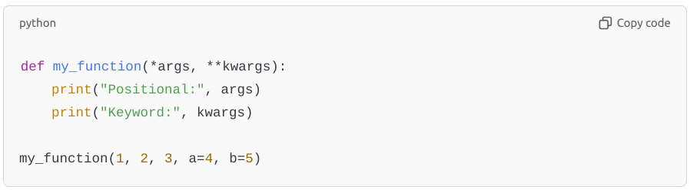
python
Copy code
def my_function(*args, **kwargs):
print("Positional:", args)
print("Keyword:", kwargs)

my_function(1, 2, 3, a=4, b=5)

23. What are weak references, and how are they useful?
Answer: Weak references allow one object to refer to another without preventing it from being garbage-collected. The weakref module in Python is useful for caching applications where you don’t want the cache itself to keep objects alive longer than needed.
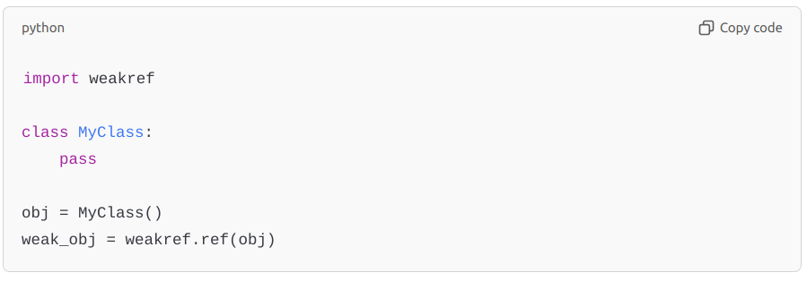
python
Copy code
import weakref

class MyClass:
pass

obj = MyClass()
weak_obj = weakref.ref(obj)

24. Explain the difference between @staticmethod, @classmethod, and instance methods.
Answer:
- Instance methods take self as the first parameter and operate on instance data.
- Class methods use @classmethod and take cls as the first parameter, operating on class-level data.
- Static methods use @staticmethod, neither taking self nor cls, and are like regular functions that live within the class’s namespace.
These questions can probe your familiarity with advanced Python concepts and patterns, as well as practical applications of Python features in real-world scenarios.

Here are additional advanced Python interview questions that explore more intricate details of the language:

25. How do you handle memory leaks in Python?
Answer: In Python, memory leaks can occur due to reference cycles, improperly managed external resources, or maintaining long-lived objects unnecessarily.
- Avoid circular references: Use weakref for objects that refer to each other to break reference cycles.
- Use the gc module: The garbage collector (gc.collect()) can help find and clean up circular references.
- Profile memory usage: Tools like memory_profiler, objgraph, and tracemalloc can identify memory leaks by tracking object allocations.
- Manage resources carefully: Use context managers (with statements) for resources like files or network connections to ensure they are released properly.

26. What are __getattr__, __getattribute__, and __setattr__ methods? How are they different?
Answer:
- __getattr__: Called only if the attribute wasn’t found the usual way. It’s useful for providing dynamic attributes or handling missing attributes.
- __getattribute__: Called every time any attribute is accessed, making it powerful but easy to misuse. It should be used cautiously, as improper use can lead to infinite recursion.
- __setattr__: Called whenever an attribute is set. It’s commonly used for validation or logging attribute changes.
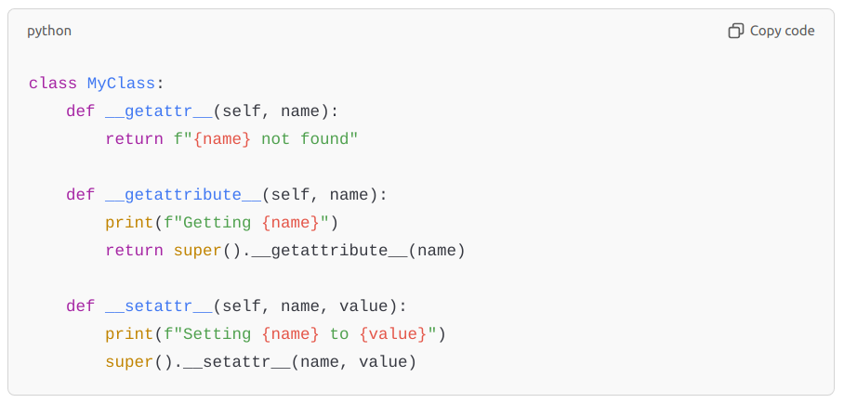
python
Copy code
class MyClass:
def __getattr__(self, name):
return f"{name} not found"

def __getattribute__(self, name):
print(f"Getting {name}")
return super().__getattribute__(name)

def __setattr__(self, name, value):
print(f"Setting {name} to {value}")
super().__setattr__(name, value)

27. What is the purpose of the nonlocal keyword?
Answer: The nonlocal keyword is used to modify a variable in an enclosing (non-global) scope. It’s useful in nested functions where you need to modify a variable in the parent function’s scope rather than the local or global scope.
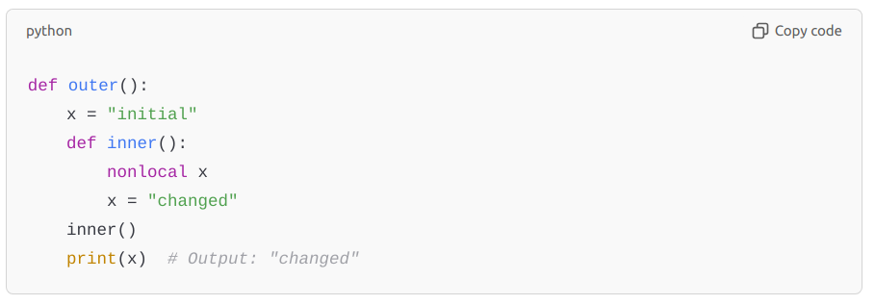
python
Copy code
def outer():
x = "initial"
def inner():
nonlocal x
x = "changed"
inner()
print(x) # Output: "changed"

28. What is the difference between a bound method and an unbound method in Python?
Answer:
- A bound method is a method associated with an instance of a class. When called, it implicitly passes the instance (self) as its first argument.
- An unbound method is simply a function defined within a class and is not bound to any specific instance. Python 3 removed explicit unbound methods; instead, you get a function if you access it on the class directly.
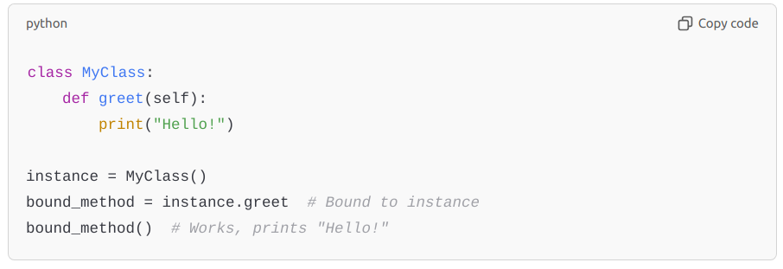
python
Copy code
class MyClass:
def greet(self):
print("Hello!")

instance = MyClass()
bound_method = instance.greet # Bound to instance
bound_method() # Works, prints "Hello!"

29. What are ABCs (Abstract Base Classes) in Python, and how do you use them?
Answer: Abstract Base Classes (ABCs) provide a way to define abstract methods that must be implemented in subclasses. They are useful for enforcing interfaces or contracts in subclasses. You use the abc module to create abstract classes and methods.
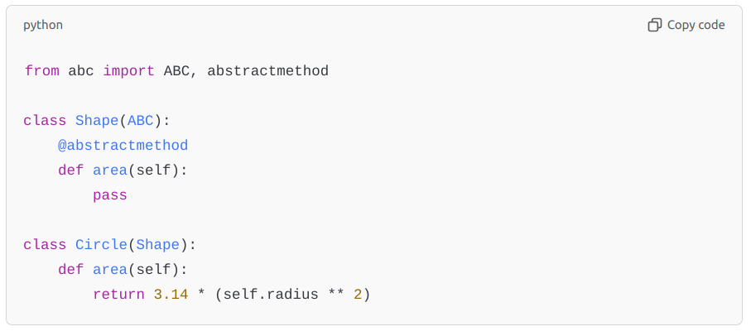
python
Copy code
from abc import ABC, abstractmethod

class Shape(ABC):
@abstractmethod
def area(self):
pass

class Circle(Shape):
def area(self):
return 3.14 * (self.radius ** 2)

30. What is method resolution order (MRO) in Python? How is it determined?
Answer: MRO is the order in which Python looks for a method in a hierarchy of classes. Python follows the C3 linearization algorithm (also known as the "C3 superclass linearization") to determine the order of classes in multiple inheritance scenarios. You can view the MRO using the __mro__ attribute or mro() method.
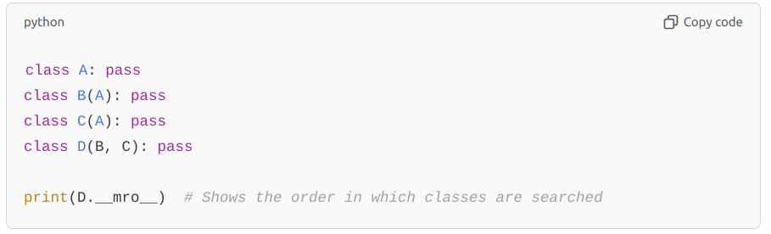
python
Copy code
class A: pass
class B(A): pass
class C(A): pass
class D(B, C): pass

print(D.__mro__) # Shows the order in which classes are searched

31. What is the difference between deepcopy and copy in Python?
Answer: copy.copy() creates a shallow copy, which means it creates a new object but does not create copies of objects within the object. copy.deepcopy() creates a deep copy, meaning it recursively copies everything, including nested objects. Shallow copies are faster and use less memory but don’t completely isolate from the original.

32. What are descriptors in Python, and how are they used?
Answer: Descriptors are objects that define how attribute access is managed in classes. They implement any of the __get__, __set__, or __delete__ methods, which can be used to control access, validation, or computed attributes in classes. Common examples are property, staticmethod, and classmethod.
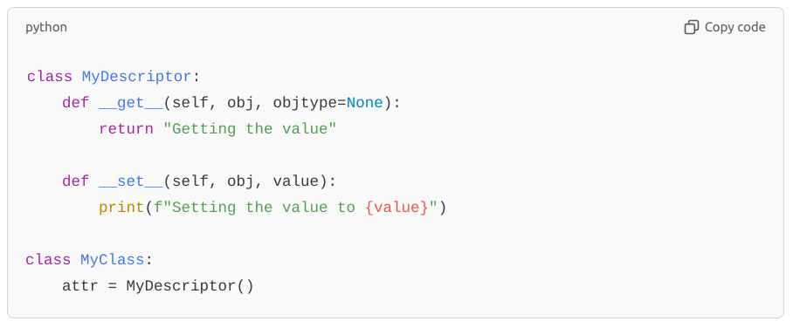
python
Copy code
class MyDescriptor:
def __get__(self, obj, objtype=None):
return "Getting the value"

def __set__(self, obj, value):
print(f"Setting the value to {value}")

class MyClass:
attr = MyDescriptor()

33. Explain the GIL and its impact on threading in Python.
Answer: The Global Interpreter Lock (GIL) is a mutex in CPython that ensures only one thread executes Python bytecode at a time, even in multi-threaded programs. This simplifies memory management but hinders CPU-bound parallelism. I/O-bound tasks (like web scraping) can still benefit from threading, but CPU-bound tasks are better handled by multiprocessing, which bypasses the GIL by creating separate processes.

34. What is the purpose of the yield keyword? How is it different from return?
Answer: yield is used in generator functions to produce a value and suspend the function’s state, allowing it to resume from where it left off on the next call. Unlike return, which exits the function, yield allows the function to be paused and resumed, making it memory efficient for handling large data streams or sequences.
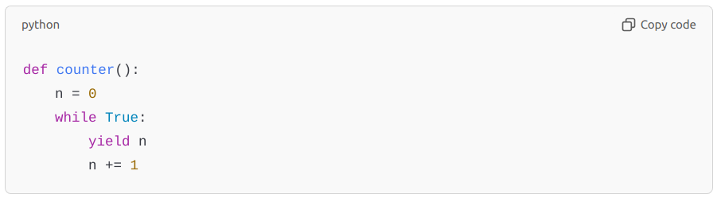
python
Copy code
def counter():
n = 0
while True:
yield n
n += 1

35. What is the purpose of the __call__ method in Python?
Answer: The __call__ method allows an instance of a class to be called as if it were a function. This can be useful for creating callable objects that behave like functions, which can help in defining flexible interfaces or implementing the strategy pattern.
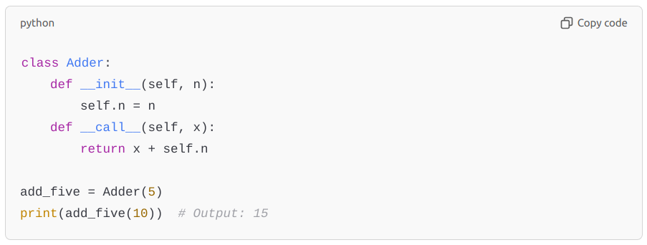
python
Copy code
class Adder:
def __init__(self, n):
self.n = n
def __call__(self, x):
return x + self.n

add_five = Adder(5)
print(add_five(10)) # Output: 15

36. Explain the purpose and use of enum.Enum in Python.
Answer: The enum.Enum class in the enum module provides a way to define symbolic names for unique, constant values. Enums improve code readability and maintainability by grouping related constants.
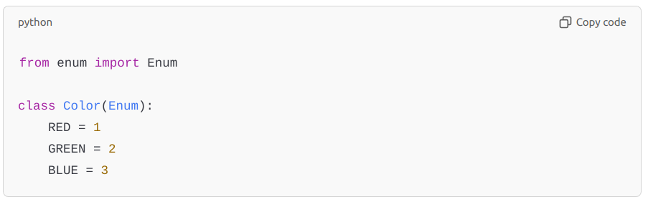
python
Copy code
from enum import Enum

class Color(Enum):
RED = 1
GREEN = 2
BLUE = 3

37. How does the @dataclass decorator work, and what are its benefits?
Answer: The @dataclass decorator from the dataclasses module simplifies the creation of classes by automatically adding generated special methods like __init__, __repr__, __eq__, and others based on class attributes. It’s particularly useful for classes meant to store data without extensive behavior.
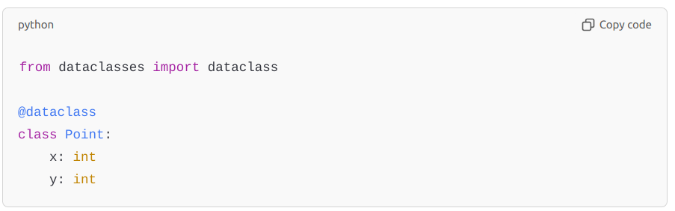
python
Copy code
from dataclasses import dataclass

@dataclass
class Point:
x: int
y: int

38. How do Python’s heapq and bisect modules work, and when would you use them?
Answer:
- heapq: Provides functions for creating and managing heaps, useful for priority queues or efficient minimum and maximum operations.
- bisect: Used for binary searching and inserting items in sorted lists, which is efficient for maintaining sorted collections.

39. What are namedtuples, and when would you use them?
Answer: namedtuple is a function in the collections module that creates a subclass of tuples with named fields. It provides a lightweight, readable way to create simple classes for storing data.
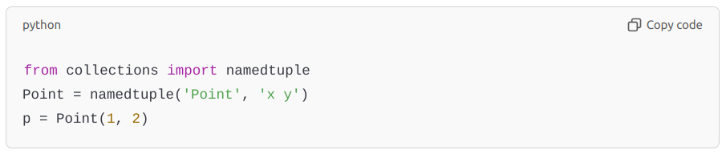
python
Copy code
from collections import namedtuple
Point = namedtuple('Point', 'x y')
p = Point(1, 2)

40. How would you implement caching in a Python function?
Answer: Caching stores results of expensive or frequently called functions to improve performance.
- functools.lru_cache: The easiest way to cache results of a function, implementing an LRU (Least Recently Used) cache.
- Custom dictionary: For more control, you can manually implement a caching dictionary.
These advanced questions cover a range of concepts including memory management, performance optimization, and design patterns in Python, all of which are common areas for discussion in experienced-level interviews.

Here are some more advanced Python interview questions, covering a variety of specialized topics and best practices:

41. How do you handle exceptions in Python? Can you create a custom exception?
Answer: Exception handling in Python is done using try, except, else, and finally blocks. Custom exceptions can be created by subclassing the built-in Exception class, allowing more meaningful error handling.
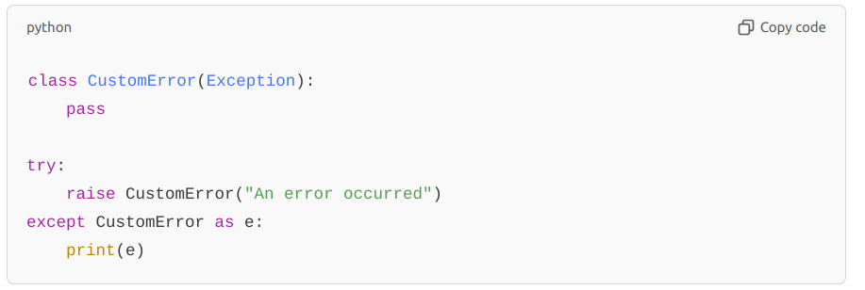
python
Copy code
class CustomError(Exception):
pass

try:
raise CustomError("An error occurred")
except CustomError as e:
print(e)

42. Explain the difference between the @classmethod and @staticmethod decorators.
Answer:
- @classmethod: Takes cls as the first argument and operates on the class rather than instances. Useful for factory methods or methods that need access to class variables.
- @staticmethod: Does not take self or cls. It is a regular function inside the class’s namespace and does not depend on class or instance state.

43. What are Python's data model "magic methods," and why are they useful?
Answer: Magic methods, also known as dunder methods (e.g., __init__, __len__, __add__), are special methods Python calls under specific conditions. They enable operator overloading and customization of built-in behavior, making classes more intuitive to use and compatible with Python's built-in functions.
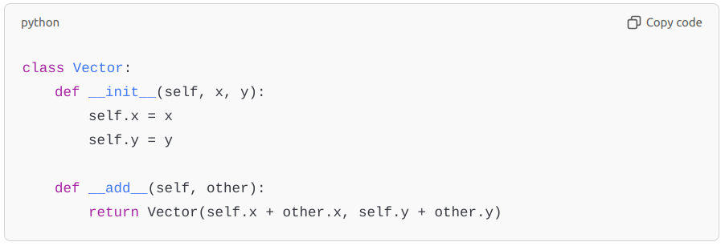
python
Copy code
class Vector:
def __init__(self, x, y):
self.x = x
self.y = y

def __add__(self, other):
return Vector(self.x + other.x, self.y + other.y)

44. How do you use the asyncio module for asynchronous programming in Python?
Answer: The asyncio module provides the foundation for asynchronous programming, allowing non-blocking I/O tasks to run concurrently. Functions are defined with async def, and await is used to pause and resume execution.
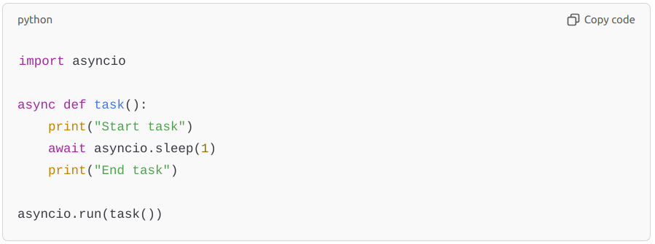
python
Copy code
import asyncio

async def task():
print("Start task")
await asyncio.sleep(1)
print("End task")

asyncio.run(task())

45. What is the purpose of __new__ in Python? How is it different from __init__?
Answer: __new__ is a special method used to create a new instance of a class, whereas __init__ initializes it. __new__ is called before __init__ and is useful in scenarios like implementing singletons or creating immutable objects.
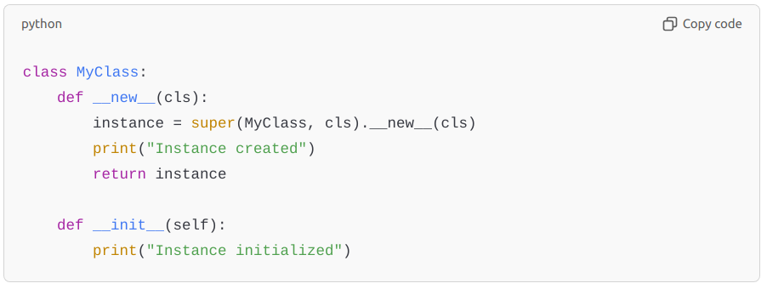
python
Copy code
class MyClass:
def __new__(cls):
instance = super(MyClass, cls).__new__(cls)
print("Instance created")
return instance

def __init__(self):
print("Instance initialized")

46. What is memoization, and how can it be implemented in Python?
Answer: Memoization is a technique where results of expensive function calls are cached to avoid redundant computations. It can be implemented using a dictionary or functools.lru_cache.
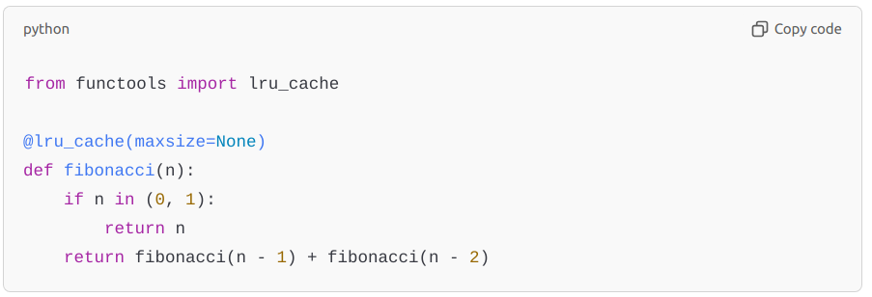
python
Copy code
from functools import lru_cache

@lru_cache(maxsize=None)
def fibonacci(n):
if n in (0, 1):
return n
return fibonacci(n - 1) + fibonacci(n - 2)

47. Explain the Observer pattern and its implementation in Python.
Answer: The Observer pattern allows an object (subject) to notify other objects (observers) of state changes. This is useful in event-driven programming.
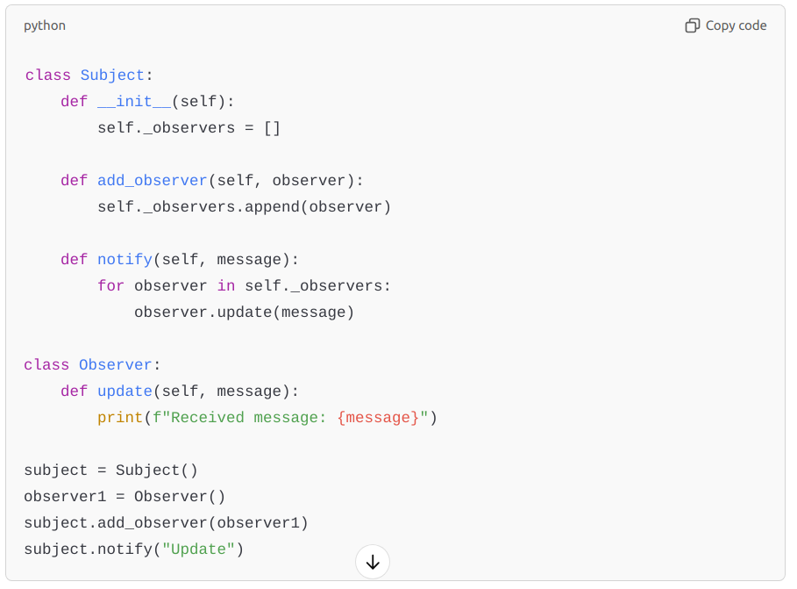
python
Copy code
class Subject:
def __init__(self):
self._observers = []

def add_observer(self, observer):
self._observers.append(observer)

def notify(self, message):
for observer in self._observers:
observer.update(message)

class Observer:
def update(self, message):
print(f"Received message: {message}")

subject = Subject()
observer1 = Observer()
subject.add_observer(observer1)
subject.notify("Update")

48. How does the copy module in Python handle deep and shallow copies?
Answer:
- copy.copy() performs a shallow copy, duplicating only the top-level structure.
- copy.deepcopy() performs a deep copy, duplicating all nested structures.
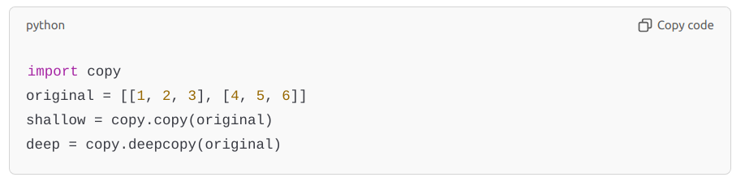
python
Copy code
import copy
original = [[1, 2, 3], [4, 5, 6]]
shallow = copy.copy(original)
deep = copy.deepcopy(original)

49. How does Python manage memory?
Answer: Python uses a combination of reference counting and garbage collection. Each object has a reference count, and when the count reaches zero, the memory is deallocated. Python’s gc module handles cyclic references with a cyclic garbage collector, which identifies and removes circular dependencies.

50. What are generators, and how are they different from regular functions?
Answer: Generators are functions that use yield instead of return. They produce items lazily, one at a time, and maintain state between calls. This makes them memory-efficient for large datasets or infinite sequences.
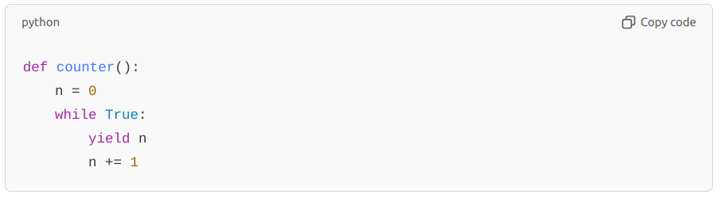
python
Copy code
def counter():
n = 0
while True:
yield n
n += 1

51. What is the purpose of __slots__, and how does it improve performance?
Answer: __slots__ restricts attribute creation to a predefined set, avoiding the creation of a __dict__ for each instance. This saves memory, especially for large numbers of instances, by not allowing dynamic attributes.

52. Explain duck typing in Python. How does it affect code flexibility?
Answer: Duck typing is a concept where an object’s behavior is more important than its class. If an object implements the necessary methods, it can be used in place of another object. This makes code more flexible, as it’s less dependent on specific classes and focuses on functionality.

53. What are weak references, and when would you use them?
Answer: Weak references allow an object to be referenced without preventing it from being garbage collected. This is useful in caches or mappings where you want to avoid memory leaks by automatically discarding objects that are no longer needed.
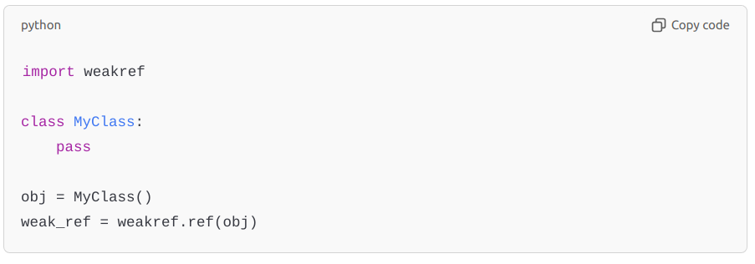
python
Copy code
import weakref

class MyClass:
pass

obj = MyClass()
weak_ref = weakref.ref(obj)

54. What is the Singleton pattern, and how do you implement it in Python?
Answer: The Singleton pattern ensures that a class has only one instance. In Python, you can implement it by overriding the __new__ method.

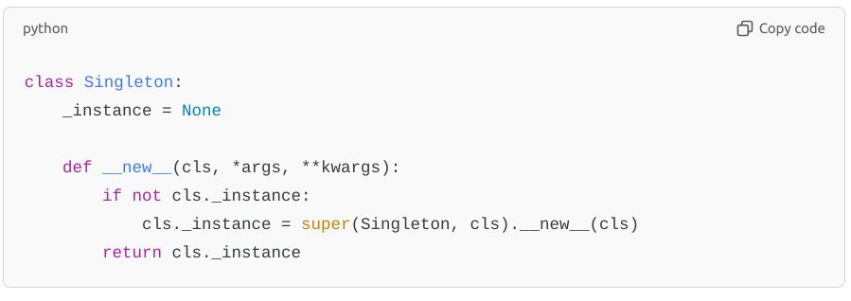
python
Copy code
class Singleton:
_instance = None

def __new__(cls, *args, **kwargs):
if not cls._instance:
cls._instance = super(Singleton, cls).__new__(cls)
return cls._instance

55. What are metaclasses, and how do they work?
Answer: Metaclasses are classes of classes—they define the behavior of classes, allowing customization of class creation. They are created by inheriting from type and can be used to modify or extend class behavior, like enforcing certain methods or properties.
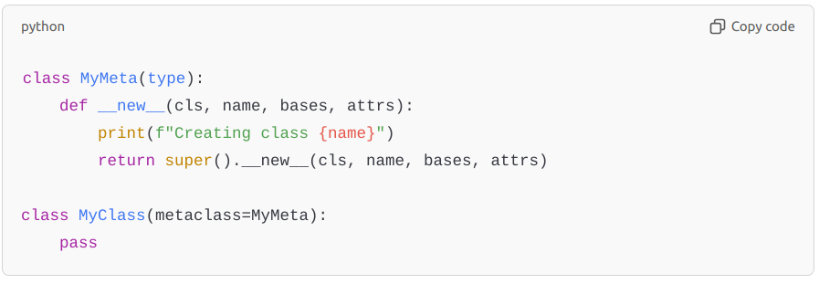
python
Copy code
class MyMeta(type):
def __new__(cls, name, bases, attrs):
print(f"Creating class {name}")
return super().__new__(cls, name, bases, attrs)

class MyClass(metaclass=MyMeta):
pass

56. Explain method overloading in Python. Is it supported natively?
Answer: Python does not support method overloading in the traditional sense. However, you can achieve similar behavior using default arguments or by checking argument types and counts manually within a method.
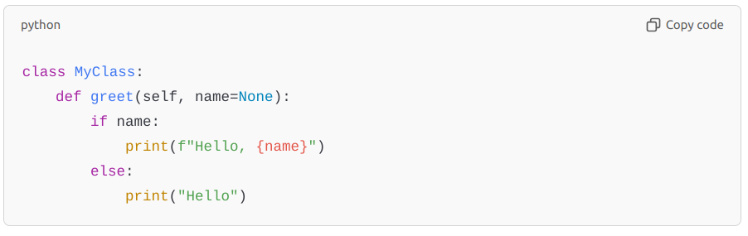
python
Copy code
class MyClass:
def greet(self, name=None):
if name:
print(f"Hello, {name}")
else:
print("Hello")

57. How does the bisect module work, and when is it useful?
Answer: The bisect module provides functions for inserting items into sorted lists and searching in them, using binary search. It’s useful for maintaining order in sorted collections efficiently.
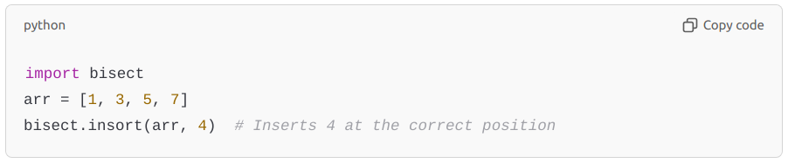
python
Copy code
import bisect
arr = [1, 3, 5, 7]
bisect.insort(arr, 4) # Inserts 4 at the correct position

58. Explain the heapq module and its use cases.
Answer: heapq provides functions for creating and manipulating heaps, which are binary trees where the smallest element is at the root. It’s useful for priority queues and finding the smallest (or largest) items in a collection.
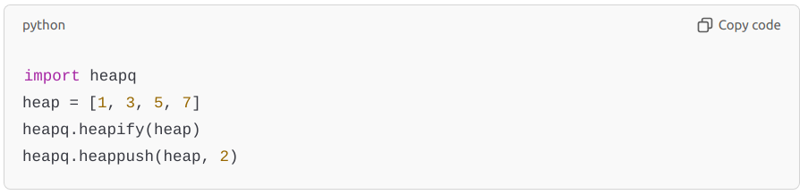
python
Copy code
import heapq
heap = [1, 3, 5, 7]
heapq.heapify(heap)
heapq.heappush(heap, 2)

59. What are namedtuples, and how do they differ from regular tuples?
Answer: namedtuple is a function from the collections module that creates tuple subclasses with named fields. Unlike regular tuples, namedtuples are more readable and provide field names for accessing elements.
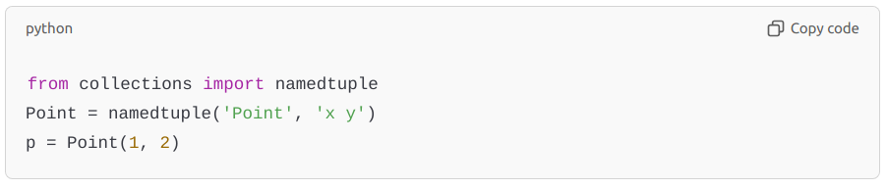
python
Copy code
from collections import namedtuple
Point = namedtuple('Point', 'x y')
p = Point(1, 2)

60. How can you profile and optimize Python code?
Answer: Profiling and optimizing involve measuring performance and reducing bottlenecks.
- cProfile: Use cProfile to get detailed stats on function calls and execution time.
- timeit: Use timeit for benchmarking specific code snippets.
- Optimizations: Common optimizations include using list comprehensions, avoiding global variables, using join for string concatenation, and utilizing numpy for array operations.
These questions dive deeper into Python’s internals, advanced data structures, performance optimization, and design patterns—ideal for experienced developers.

Here are additional advanced Python interview questions that do not repeat previous topics. These cover more specialized and niche Python concepts.

61. What are Python context managers, and how do they work under the hood?
Answer: Context managers are used to set up a context for resource management, ensuring that resources are properly acquired and released. They’re typically used with the with statement. A context manager must define __enter__ and __exit__ methods. __enter__ is executed when the block starts, and __exit__ is executed when the block exits, regardless of whether an exception occurred.
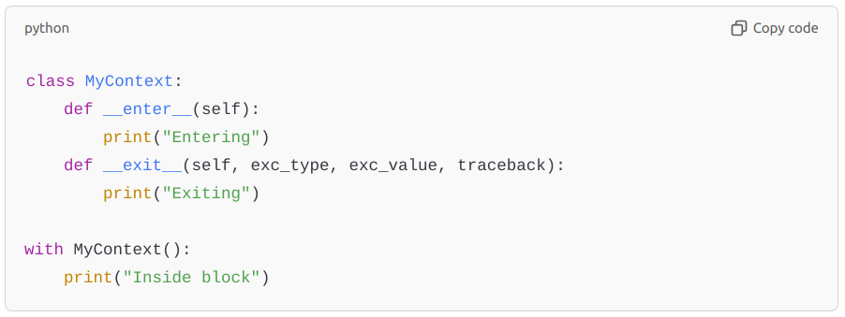
python
Copy code
class MyContext:
def __enter__(self):
print("Entering")
def __exit__(self, exc_type, exc_value, traceback):
print("Exiting")

with MyContext():
print("Inside block")

62. What are type annotations in Python, and how are they used for static type checking?
Answer: Type annotations provide hints about the types of variables and function parameters, allowing for static type checking with tools like mypy. Annotations do not enforce types at runtime but help with readability, documentation, and debugging.
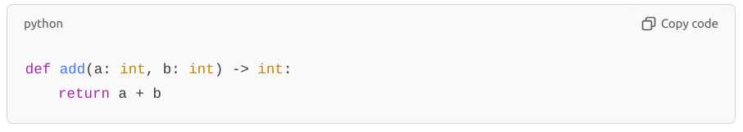
python
Copy code
def add(a: int, b: int) -> int:
return a + b

63. How does the collections.deque differ from a list? When would you use it?
Answer: deque (double-ended queue) is optimized for fast appends and pops from both ends (O(1) complexity) compared to lists, which are optimized for fast access and modification but slower for inserts/removals from the start. deque is ideal for queues, stacks, or sliding windows.
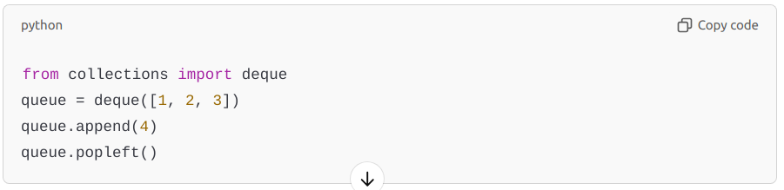
python
Copy code
from collections import deque
queue = deque([1, 2, 3])
queue.append(4)
queue.popleft()

64. What is a coroutine in Python, and how does it differ from a regular function?
Answer: A coroutine is a special type of function defined with async def that can pause execution with await, allowing it to perform asynchronous tasks. Coroutines yield control back to the event loop, making them suitable for handling tasks like I/O-bound operations without blocking the program.
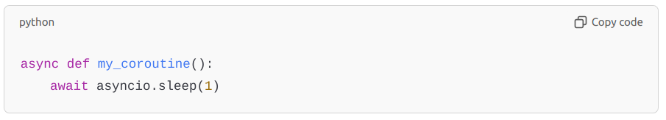
python
Copy code
async def my_coroutine():
await asyncio.sleep(1)

65. Explain the purpose of the functools.partial function.
Answer: functools.partial allows you to fix a certain number of arguments for a function, creating a new function with fewer arguments. It’s useful when you need a function with specific arguments in contexts where the original function signature does not match.
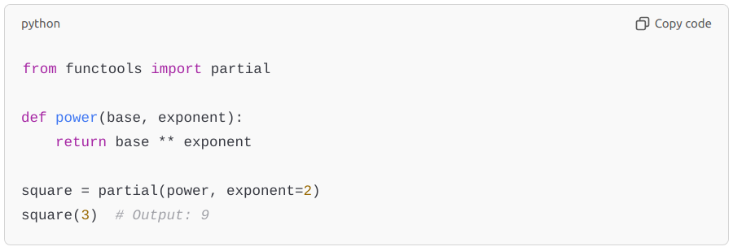
python
Copy code
from functools import partial

def power(base, exponent):
return base ** exponent

square = partial(power, exponent=2)
square(3) # Output: 9

66. What is the purpose of the itertools module, and can you give examples of commonly used functions?
Answer: The itertools module provides efficient looping tools for working with iterators. Common functions include:
- count(): Creates an infinite iterator.
- cycle(): Cycles through an iterable indefinitely.
- chain(): Concatenates multiple iterables.
- combinations(): Generates combinations of items.
- product(): Computes the Cartesian product of input iterables.
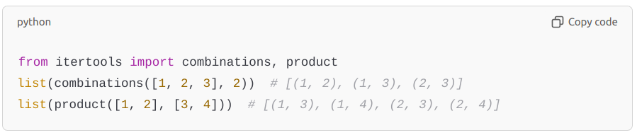
python
Copy code
from itertools import combinations, product
list(combinations([1, 2, 3], 2)) # [(1, 2), (1, 3), (2, 3)]
list(product([1, 2], [3, 4])) # [(1, 3), (1, 4), (2, 3), (2, 4)]

67. What is __slots__ in Python, and how does it affect memory usage?
Answer: __slots__ is a class variable that can be used to explicitly declare data attributes, which prevents Python from creating a __dict__ for each instance, thus saving memory. This is especially beneficial in memory-sensitive applications with many instances of a class.
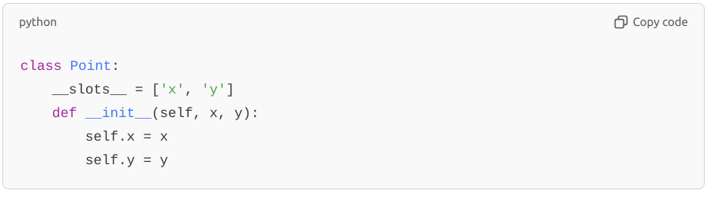
python
Copy code
class Point:
__slots__ = ['x', 'y']
def __init__(self, x, y):
self.x = x
self.y = y

68. How do you create and use a thread-safe data structure in Python?
Answer: The queue.Queue class provides a thread-safe FIFO implementation by handling internal locking. Alternatively, Python’s threading module allows the use of locks (e.g., threading.Lock) to make data structures like lists or dictionaries thread-safe.
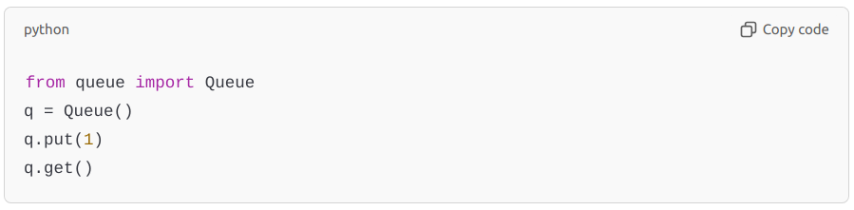
python
Copy code
from queue import Queue
q = Queue()
q.put(1)
q.get()

69. What is the super() function, and how does it work with multiple inheritance?
Answer: super() is used to call a method from a parent class, usually in the context of inheritance. It works with Python’s method resolution order (MRO) to ensure that the next class in line is called, making it useful for multiple inheritance scenarios.
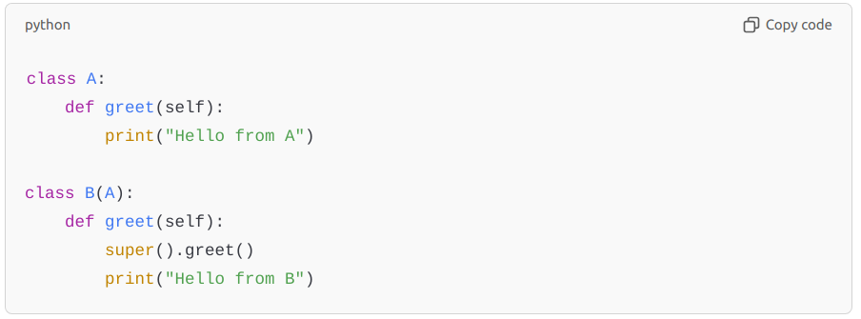
python
Copy code
class A:
def greet(self):
print("Hello from A")

class B(A):
def greet(self):
super().greet()
print("Hello from B")

70. What is the purpose of abc.ABC in Python, and how do you enforce abstract methods?
Answer: abc.ABC is a base class in Python’s abc (abstract base classes) module that allows for the creation of abstract classes. Classes that inherit from abc.ABC can define abstract methods with the @abstractmethod decorator, forcing subclasses to implement them.
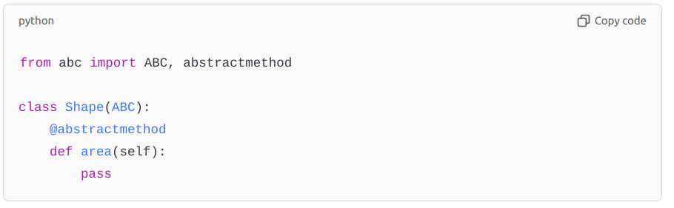
python
Copy code
from abc import ABC, abstractmethod

class Shape(ABC):
@abstractmethod
def area(self):
pass

71. Explain the purpose of sys.setrecursionlimit in Python.
Answer: Python has a default recursion limit (usually 1000), which prevents excessive memory use from too-deep recursive calls. sys.setrecursionlimit() can increase this limit if a program needs deeper recursion (e.g., deep tree traversal), but setting it too high can cause crashes or memory issues.

72. What are dataclasses, and what are the benefits of using them in Python 3.7+?
Answer: dataclasses is a module introduced in Python 3.7 that provides a decorator for automatically generating boilerplate code for classes that primarily store data. It automatically adds methods like __init__, __repr__, and __eq__, making data handling more concise and readable.
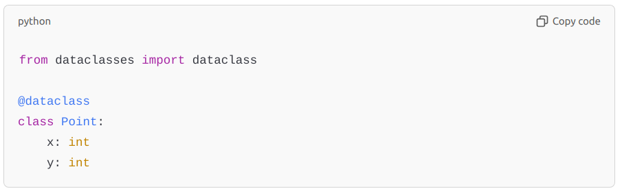
python
Copy code
from dataclasses import dataclass

@dataclass
class Point:
x: int
y: int

73. What is the purpose of the hash() function in Python?
Answer: The hash() function returns a hash value for an object if it’s hashable, which is used to quickly compare dictionary keys and set elements. Immutable data types like strings and tuples are hashable, while lists and dictionaries are not.
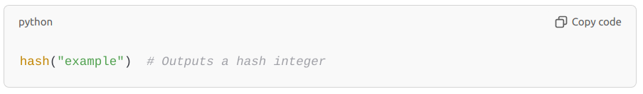
python
Copy code
hash("example") # Outputs a hash integer

74. Explain lambda functions and their typical use cases.
Answer: Lambda functions are anonymous, one-line functions defined with lambda. They are often used for small functions that are passed as arguments to higher-order functions like map(), filter(), and sorted().
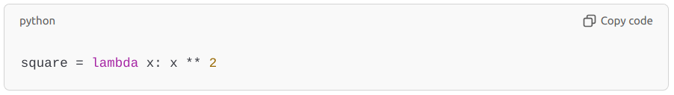
python
Copy code
square = lambda x: x ** 2

75. What are weak references, and how does the weakref module work?
Answer: Weak references allow you to reference an object without preventing its garbage collection. This is useful for caches where you don’t want the referenced object to stay in memory if there are no strong references to it.
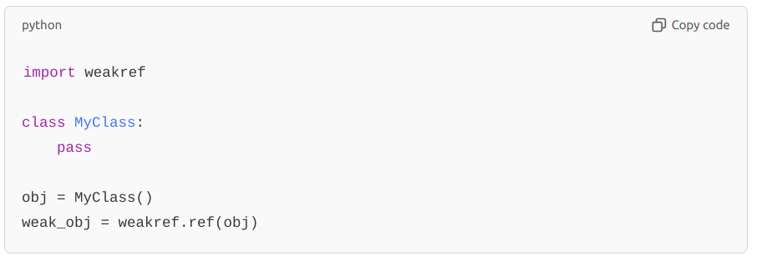
python
Copy code
import weakref

class MyClass:
pass

obj = MyClass()
weak_obj = weakref.ref(obj)

76. How would you create a custom iterable object?
Answer: To make an object iterable, implement the __iter__ and __next__ methods. __iter__ returns the iterator object itself, and __next__ defines how items are retrieved.
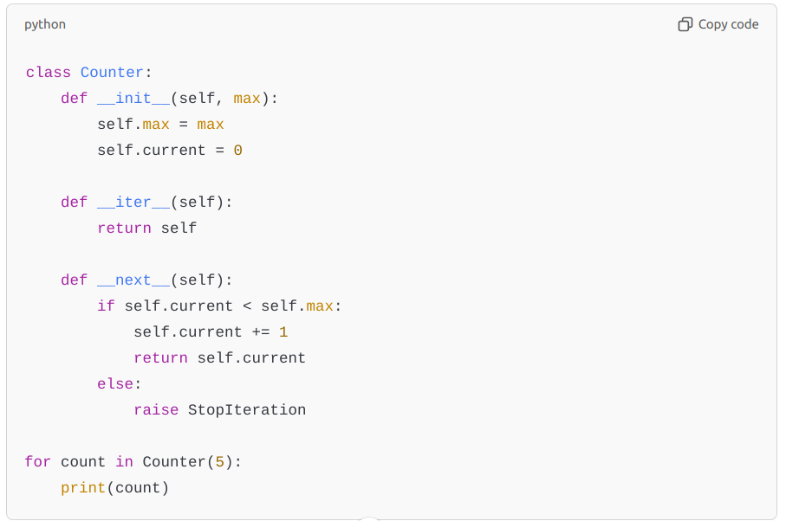
python
Copy code
class Counter:
def __init__(self, max):
self.max = max
self.current = 0

def __iter__(self):
return self

def __next__(self):
if self.current < self.max:
self.current += 1
return self.current
else:
raise StopIteration

for count in Counter(5):
print(count)

77. Explain the difference between deep and shallow copying in Python.
Answer: Shallow copying creates a new object, but nested objects remain references to the original. Deep copying, using copy.deepcopy(), recursively copies all levels, creating entirely independent objects.

78. How would you handle timezone-aware and naive datetime objects in Python?
Answer: Python’s datetime module supports timezone-aware and naive datetimes. Use datetime.replace(tzinfo=timezone.utc) to convert naive to aware and astimezone() to convert between timezones. The pytz library can also handle timezones effectively.

79. What is the difference between __getattr__ and __getattribute__?
Answer:
- __getattr__ is called only if the attribute wasn’t found the usual way.
- __getattribute__ is called for all attribute accesses, making it more powerful but also riskier if not carefully implemented due to potential infinite recursion.

80. Explain the difference between copy and deepcopy in the copy module.
Answer: copy.copy() creates a shallow copy, duplicating the top-level object but not nested structures. copy.deepcopy() creates a deep copy, duplicating everything recursively.

need 100 tough questions but please do not repeat questions
Here’s an extended list of 100 unique, advanced Python interview questions. They cover a broad range of topics, from core language mechanics to libraries, frameworks, design patterns, optimization, and system-level integrations. Each question is unique and focuses on different aspects of Python.

Core Python Concepts
- How do Python’s global and nonlocal keywords differ? Give an example of each.
- Explain the role of __name__ == "__main__" and why it is used.
- What is metaprogramming in Python? Give an example of a metaclass use case.
- How does Python implement polymorphism, and what are some common use cases?
- Discuss the impact of dynamic typing in Python on performance and debugging.
- What are *args and **kwargs, and how do they work in function definitions?
- How would you prevent memory leaks in Python applications?
- What is the difference between is and == in Python, and when is each appropriate?
- Explain duck typing with an example. How does it contribute to Python’s flexibility?
- How does Python handle method resolution order (MRO) in multiple inheritance scenarios?
- Explain the difference between deep and shallow copying with examples.
- How does Python implement namespaces and scope resolution?
- How do mutable default arguments behave in function definitions?
- What is the purpose of the __del__ method, and when should it be used cautiously?
- Explain Python’s garbage collection mechanism, especially the role of reference counting and the garbage collector.

Data Structures and Algorithms
- How do lists and tuples differ in terms of memory efficiency and use cases?
- Describe the time complexity of searching and inserting elements in lists, dictionaries, and sets.
- How would you implement a stack using only Python lists?
- What is a priority queue, and how can it be implemented using the heapq module?
- Explain how binary trees can be represented in Python.
- How can you implement a linked list in Python without using built-in data structures?
- What are named tuples, and when are they more advantageous than dictionaries?
- How does Python’s OrderedDict differ from a regular dictionary in Python 3.6+?
- What is a trie, and how would you implement it in Python?
- Describe how hash tables work and how they are implemented in Python dictionaries.

Functional Programming
- What are closures, and how are they implemented in Python?
- Explain the difference between map, filter, and reduce with examples.
- How would you implement a recursive function with a base case and recursive case?
- How does Python’s partial function work, and when would you use it?
- What is function currying, and how can it be implemented in Python?
- Explain the benefits and drawbacks of using anonymous functions (lambda).
- What is a generator expression, and how does it differ from a list comprehension?
- How would you use functools.wraps to preserve metadata in a decorator?
- Explain the concept of tail recursion and its limitations in Python.
- How do you implement function overloading in Python, given that it doesn’t support it natively?

Concurrency and Parallelism
- Explain the Global Interpreter Lock (GIL) and its implications on multi-threading.
- How does Python’s threading module differ from multiprocessing?
- What is asynchronous programming, and how does it differ from multithreading?
- How do async and await work in Python’s asyncio library?
- Explain how you would handle concurrent network requests with asyncio.
- What is the concurrent.futures module, and how does it differ from asyncio?
- Explain how Python’s Queue class helps in managing data flow in multi-threaded applications.
- What is a semaphore, and how is it used in Python for resource management?
- Explain deadlock and race conditions, and how you would avoid them in Python.
- How would you implement a producer-consumer model in Python?

Python Modules and Libraries
- How does Python’s logging module work, and why is it preferred over print statements?
- Explain the purpose and use of argparse for command-line argument parsing.
- What is the pathlib module, and how does it improve file path handling?
- How would you securely manage passwords and sensitive information in Python?
- What is the purpose of contextlib and the @contextmanager decorator?
- How would you use the subprocess module to execute shell commands in Python?
- What are the benefits of using pytest for testing in Python?
- How does unittest.mock facilitate testing, and what are some common use cases?
- How does the datetime module handle time zones, and how do you convert between them?
- Explain the difference between json and pickle for serialization in Python.

Web Development with Django and Flask
- How does Django’s ORM work, and what are some of its strengths and limitations?
- Explain the purpose of Django middleware and how it can be customized.
- What are Django signals, and how do they help in event-driven programming?
- How does Flask differ from Django in terms of project structure and scalability?
- Explain the use of the request and session objects in Flask applications.
- How would you manage database transactions in Django to ensure data integrity?
- What is the purpose of migrations in Django, and how do you handle complex migrations?
- How does Django’s QuerySet caching work, and when should it be used cautiously?
- Explain cross-site scripting (XSS) and how Django prevents it.
- How would you handle file uploads in a Django or Flask application?

Testing and Debugging
- Explain the role of pytest fixtures and how they improve test organization.
- How do you use doctest to write tests directly in Python documentation?
- What is code coverage, and how do you measure it in Python?
- How do assert statements work in Python, and when should they be avoided?
- How would you use pdb for debugging complex Python applications?
- What is property-based testing, and how does it differ from unit testing?
- Explain test-driven development (TDD) and its benefits in Python development.
- How do you handle flaky tests in an automated testing suite?
- What is a mock, and how does it differ from a stub or a fake in testing?
- How does the unittest framework’s setUp and tearDown methods help manage test state?

Advanced Data Handling and Analytics
- How does Pandas handle missing data, and what are common strategies for managing it?
- Explain the difference between .loc[], .iloc[], and .at[] in Pandas.
- How does vectorization improve performance in NumPy?
- What are broadcasting rules in NumPy, and how do they impact array operations?
- Explain how Dask handles parallel processing for large data in Python.
- How would you merge multiple dataframes in Pandas and handle conflicts?
- What is map-reduce, and how would you implement it in Python?
- How would you use groupby() and agg() in Pandas to summarize data efficiently?
- How does Python’s pickle module work, and when should it be used cautiously?
- Explain hierarchical indexing in Pandas and when it is useful.

Machine Learning and Data Science
- How does scikit-learn handle categorical data? Explain with an example.
- Explain the purpose of train_test_split and cross-validation in model evaluation.
- How would you use Python to detect and handle multicollinearity in a dataset?
- What is hyperparameter tuning, and how can it be implemented in Python?
- How does pandas.DataFrame.apply() improve data transformation over looping?
- Explain the difference between regularization techniques like Lasso and Ridge in scikit-learn.
- How would you handle class imbalance in a dataset for machine learning?
- Explain feature engineering and give examples of common transformations.
- How does Python’s matplotlib library handle subplots and figure layouts?
- What is PCA (Principal Component Analysis), and how is it implemented in Python?

Miscellaneous Advanced Topics
- Explain the difference between synchronous and asynchronous execution in web scraping.
- How would you handle version control for Python dependencies?
- What is dependency injection, and how can it be implemented in Python?
- Explain the SOLID principles and how they apply to Python application design.
- Describe the Singleton design pattern and how to implement it in Python.

These questions span critical areas relevant to advanced Python developers, including language specifics, data structures, functional and OOP concepts, performance, concurrency, popular libraries, testing, and data science. Together, they provide a strong foundation for assessing a candidate's depth and breadth of Python knowledge.

